Machine description | Kioptrix lvl-1
Target IP | 192.168.0.107
Vulnerability | Samba < 2.2.x (Linux/BSD) - Remote Code Execution
Port no /service | 139 smb
severity | 8.8 High
Attack vector | CVSS:3.1/AV:A/AC:L/PR:N/UI:N/S:U/C:H/I:H/A:H
POC (Proof of Concept) | Step 1: - Finding the host in the network  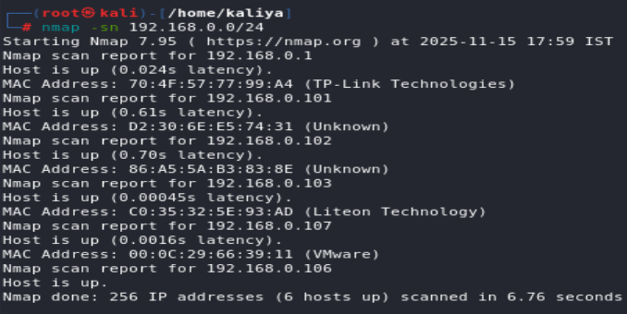  Step 2: - Checking which ports and services are running on vulnerable machine.  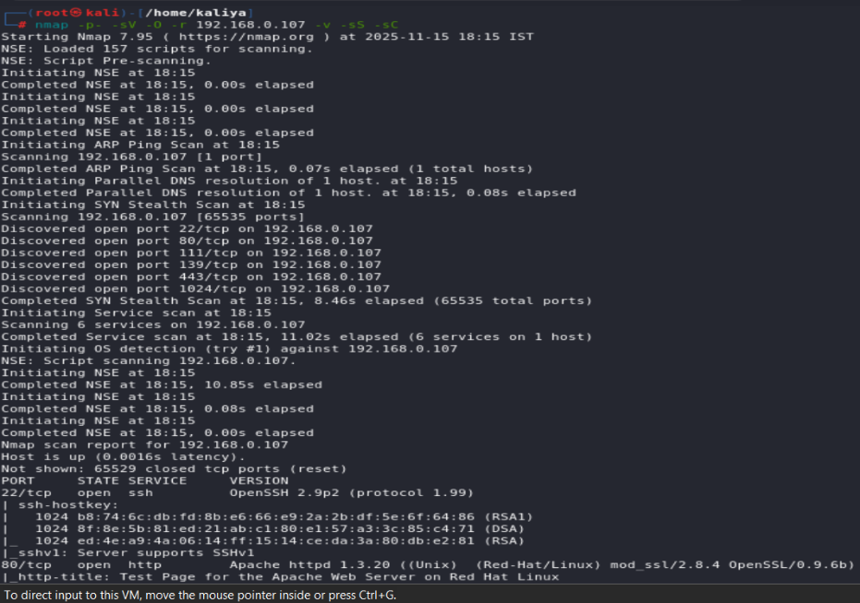  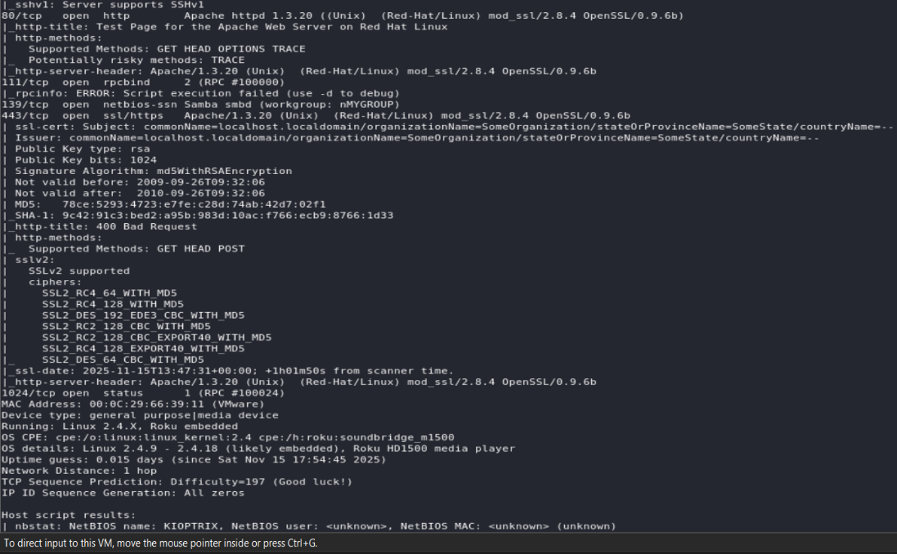  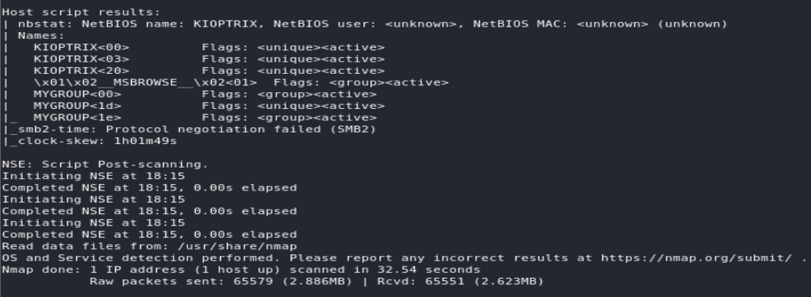  Step 3: - We now have discovered that the smb port is open, but we don't know what version it's running on, so we'll use Metasploit to find out.  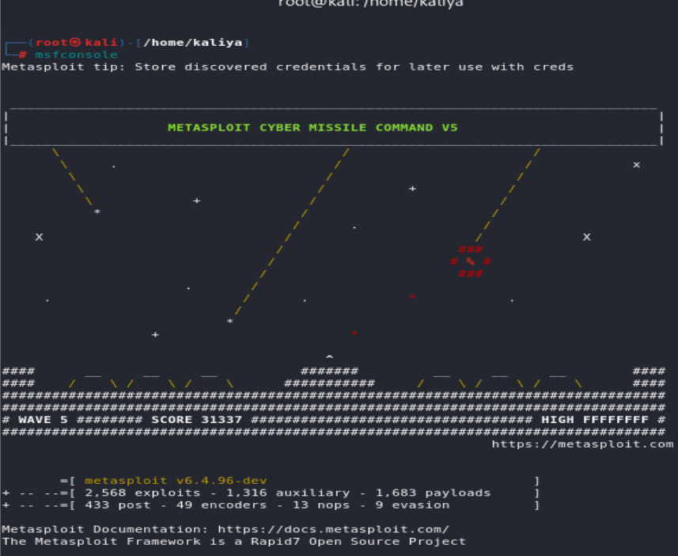  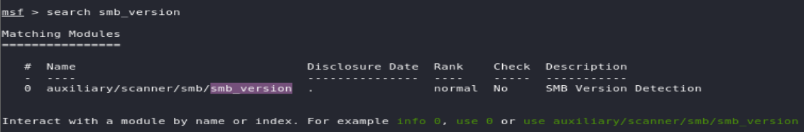  Step 4: - After selecting Module, we need to set the target IP value in RHOSTS.  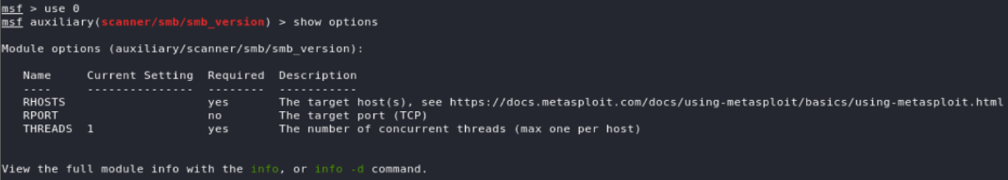\  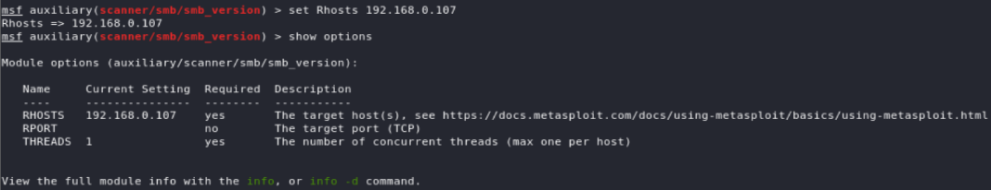  Step 5: - After executing the scanner module, we will know what is the version of smb which is (smb 2.2.1a).  Step 6: - We will also try manually connecting to the SMB port, but it will be ineffective because we do not have root access, but anonymous access is possible.  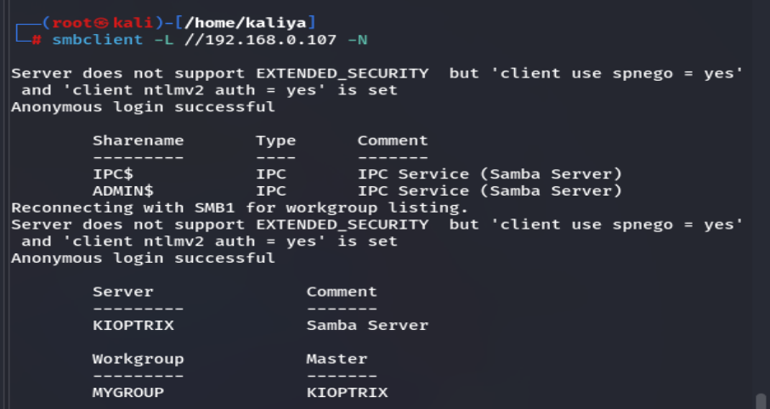  Step 7: - We will now search for the smb version in Metasploit and exploit it.  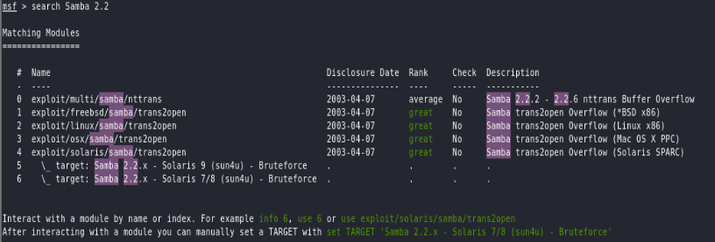  Step 8: - After selecting suitable exploit module, we will set target host Ip in RHOSTS.  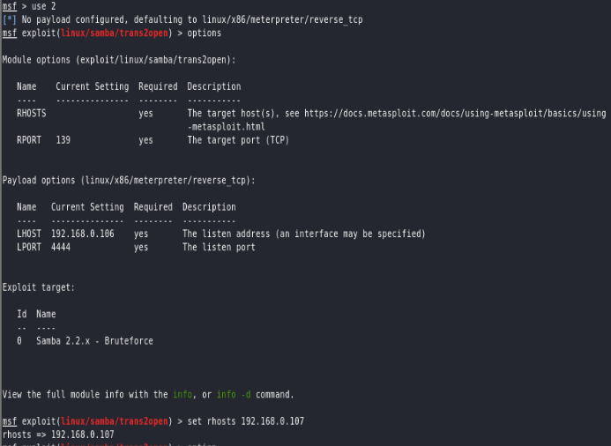  p.t.o  Step 9: - We must set the pay load before running the exploit; otherwise, we will not be able to exploit. After running the exploit, you should be able to gain access to the smb root and create a user and password for that user. Now, login with that user name and password in the kioptrix virtual machine.  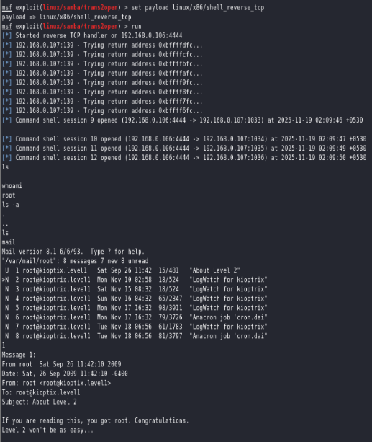
Impact | This vulnerability lets an attacker run their own commands on the server. If they exploit it, they can take control of the system, steal or change files, and possibly move to other computers on the network. It is a critical security risk.
Remediation | - Update Samba to the latest stable version immediately, as versions below 2.2.x are vulnerable.  - If updating is not possible, disable or restrict access to the Samba service from untrusted networks.  - Use firewall rules to allow Samba only from trusted IP addresses.  - Regularly patch and update the operating system and services to avoid similar issues.
Reference | - https://www.rapid7.com/db/modules/exploit/linux/samba/trans2open/  - https://www.exploit-db.com/exploits/10  - https://www.tenable.com/plugins/nessus/122056

